ACTIVITY-4
NAME- CH. Venkata chandu
REG NO- 192424140
COURSE CODE-DSA 0603
COURSE NAME- DATA HANDLING AND VISUALISATIONS

Question 1 Empirical Cumulative Distribution Function (ECDF
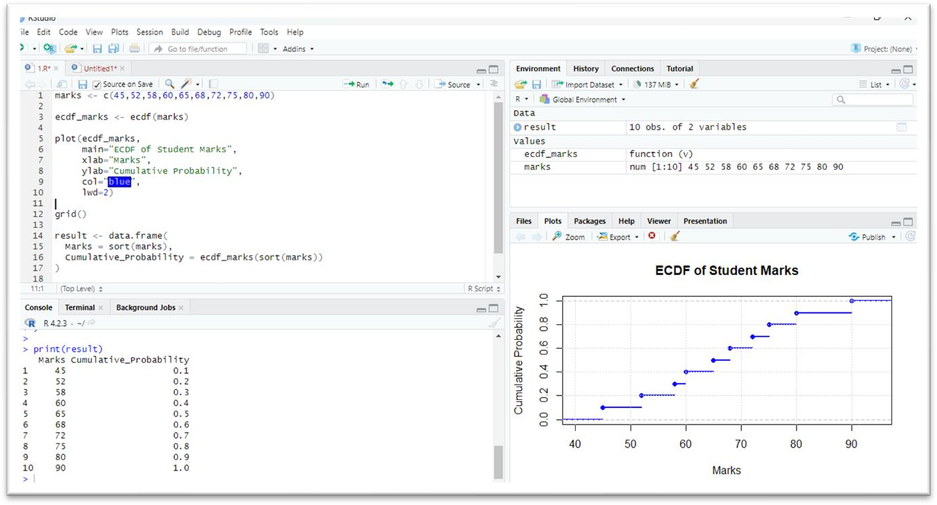

Question 2 – Empirical Cumulative Distribution Function (ECDF)
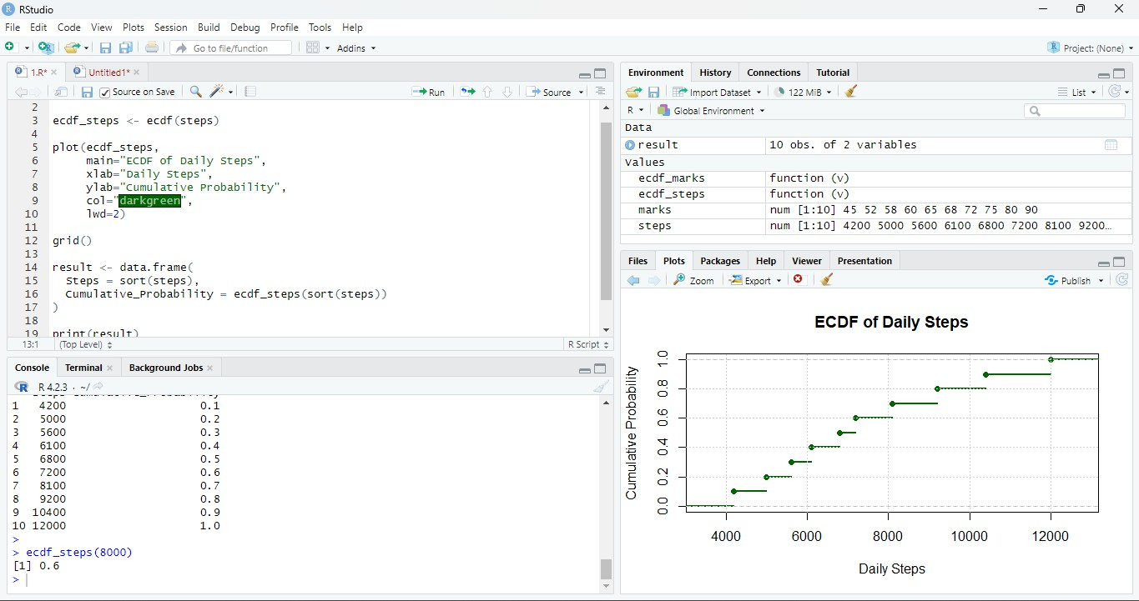

Question 3 – Highly Skewed Distribution (Histogram and Density Plot)
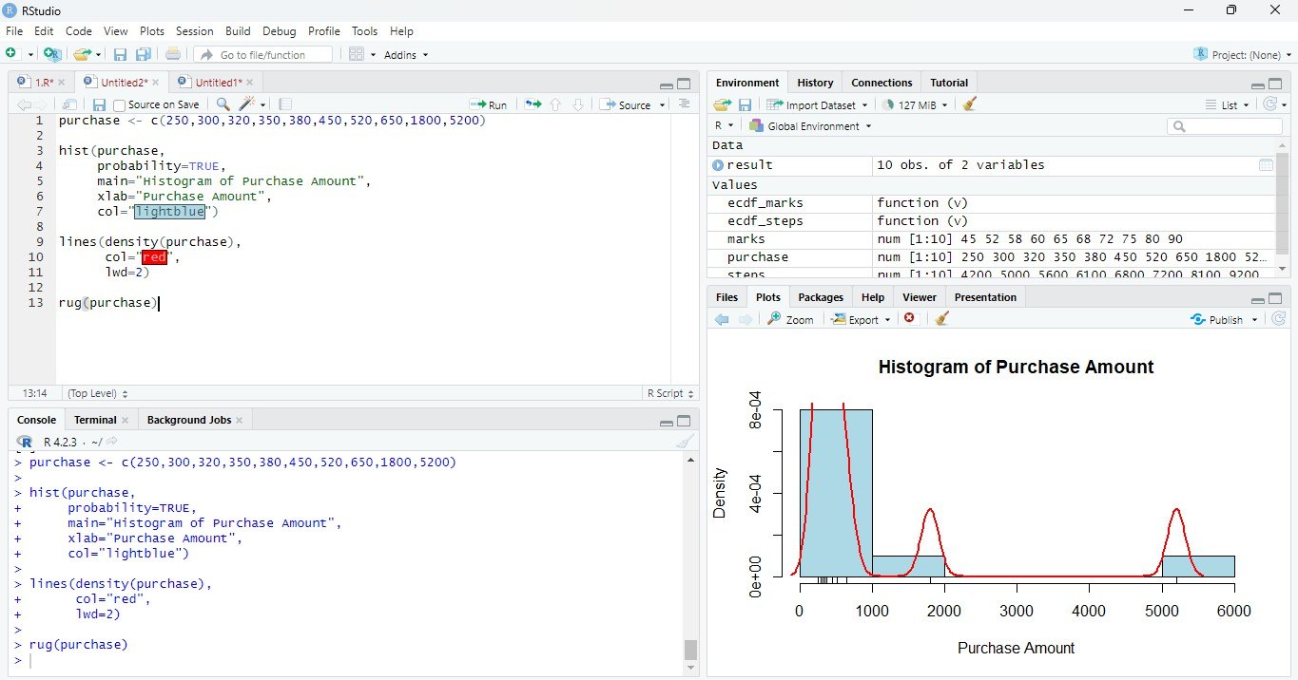

Question 4 – Quantile-Quantile (Q-Q) Plot
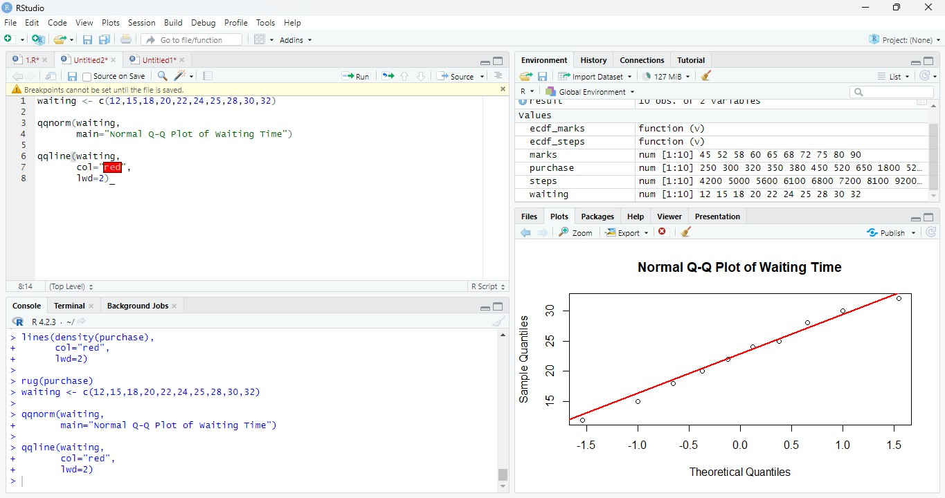

Question 5 – Highly Skewed Distribution and Q-Q Plot
